5.121: If the block is not to move vertically, the acceleration must be horizontal. The common acceleration is 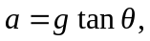 so the applied force must be 